Advanced SQL
Return Data From a Stored Procedure:
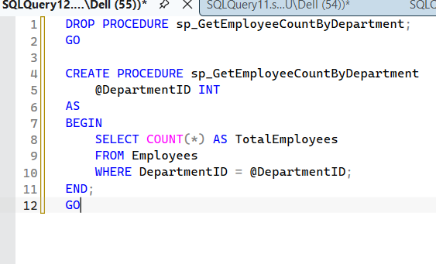
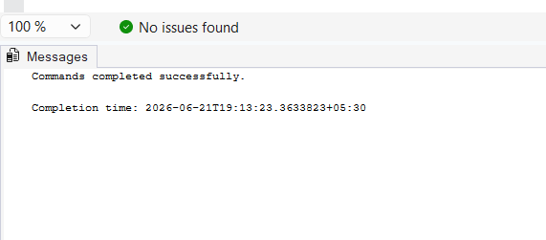
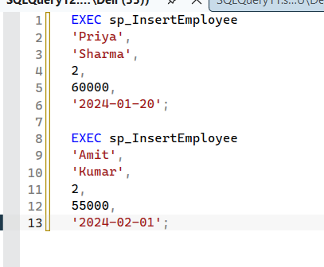
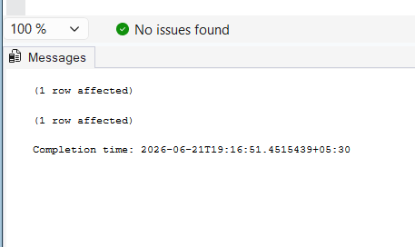
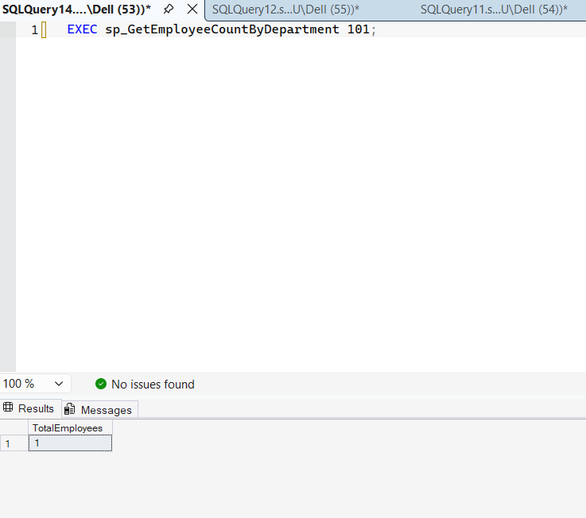
Theory
A Stored Procedure is a precompiled collection of SQL statements stored in the database. It can be executed whenever required and helps improve code reusability and performance.
In this exercise, a stored procedure named sp_GetEmployeeCountByDepartment is created to return the total number of employees in a specific department. The procedure accepts DepartmentID as an input parameter and uses the COUNT() function to calculate the number of employees belonging to that department.
Benefits:: Reusable database code
- Improved performance
- Reduced code duplication

